Freeform Curvilinear Shapes
# Source: AI Source: Provided by: [Data Path: Persons Table -> ID Column: 1, Name_En Column: Motasem Essam] -> From: [ChatGPT] on [7/25/2026]
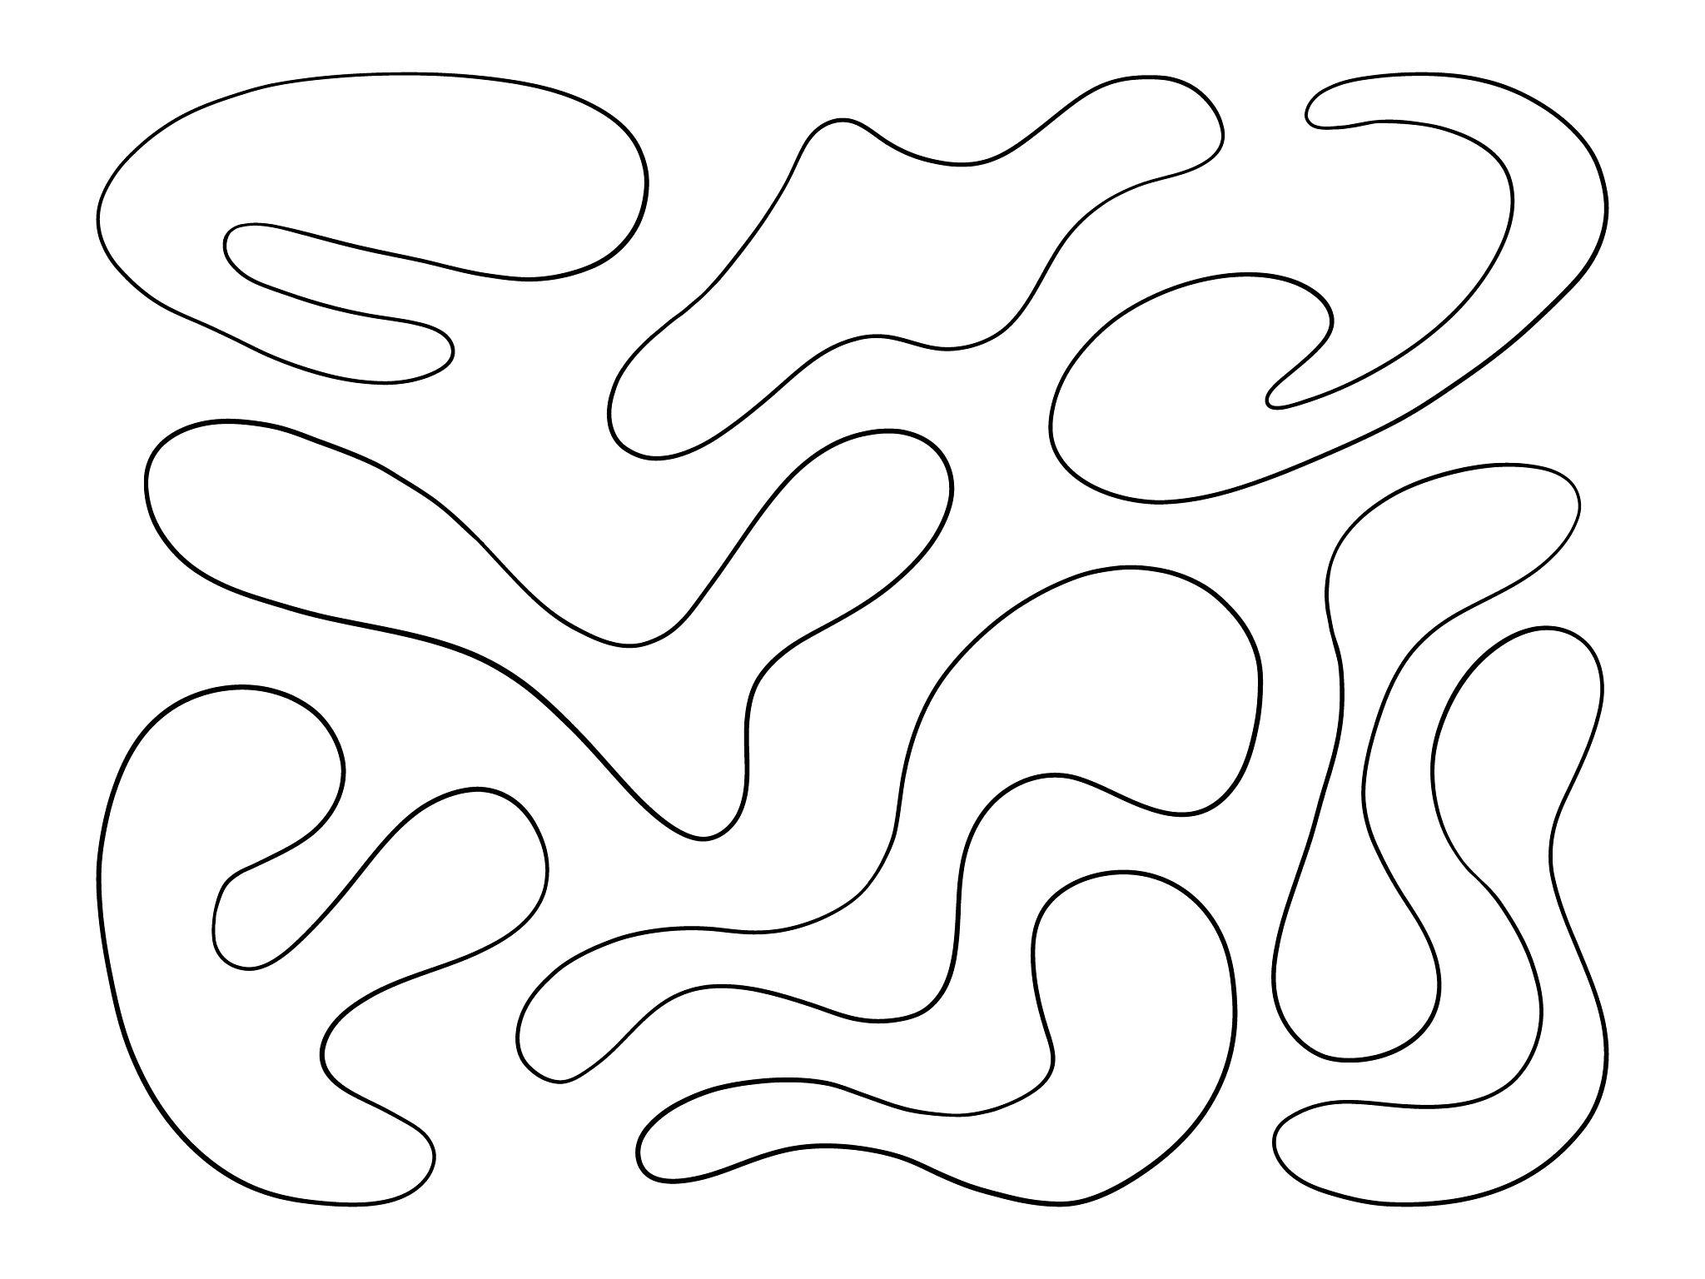
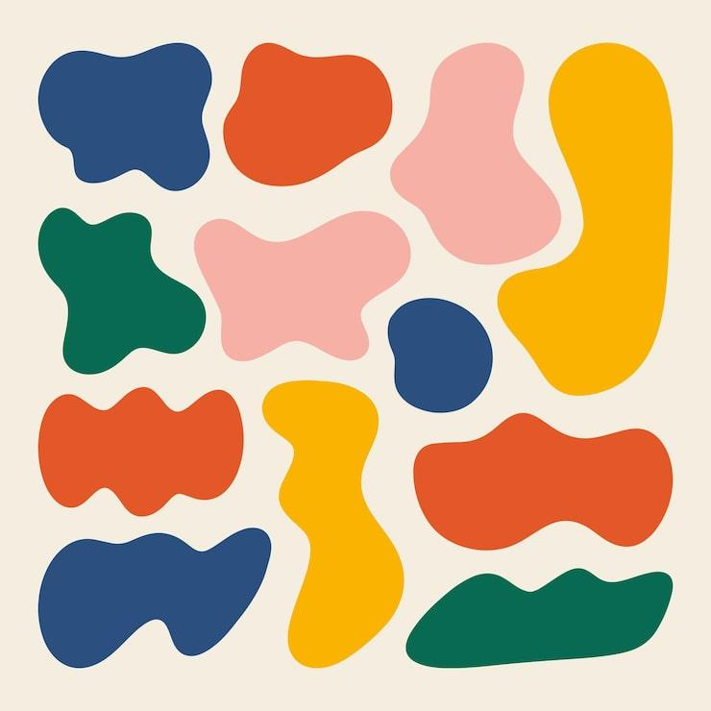
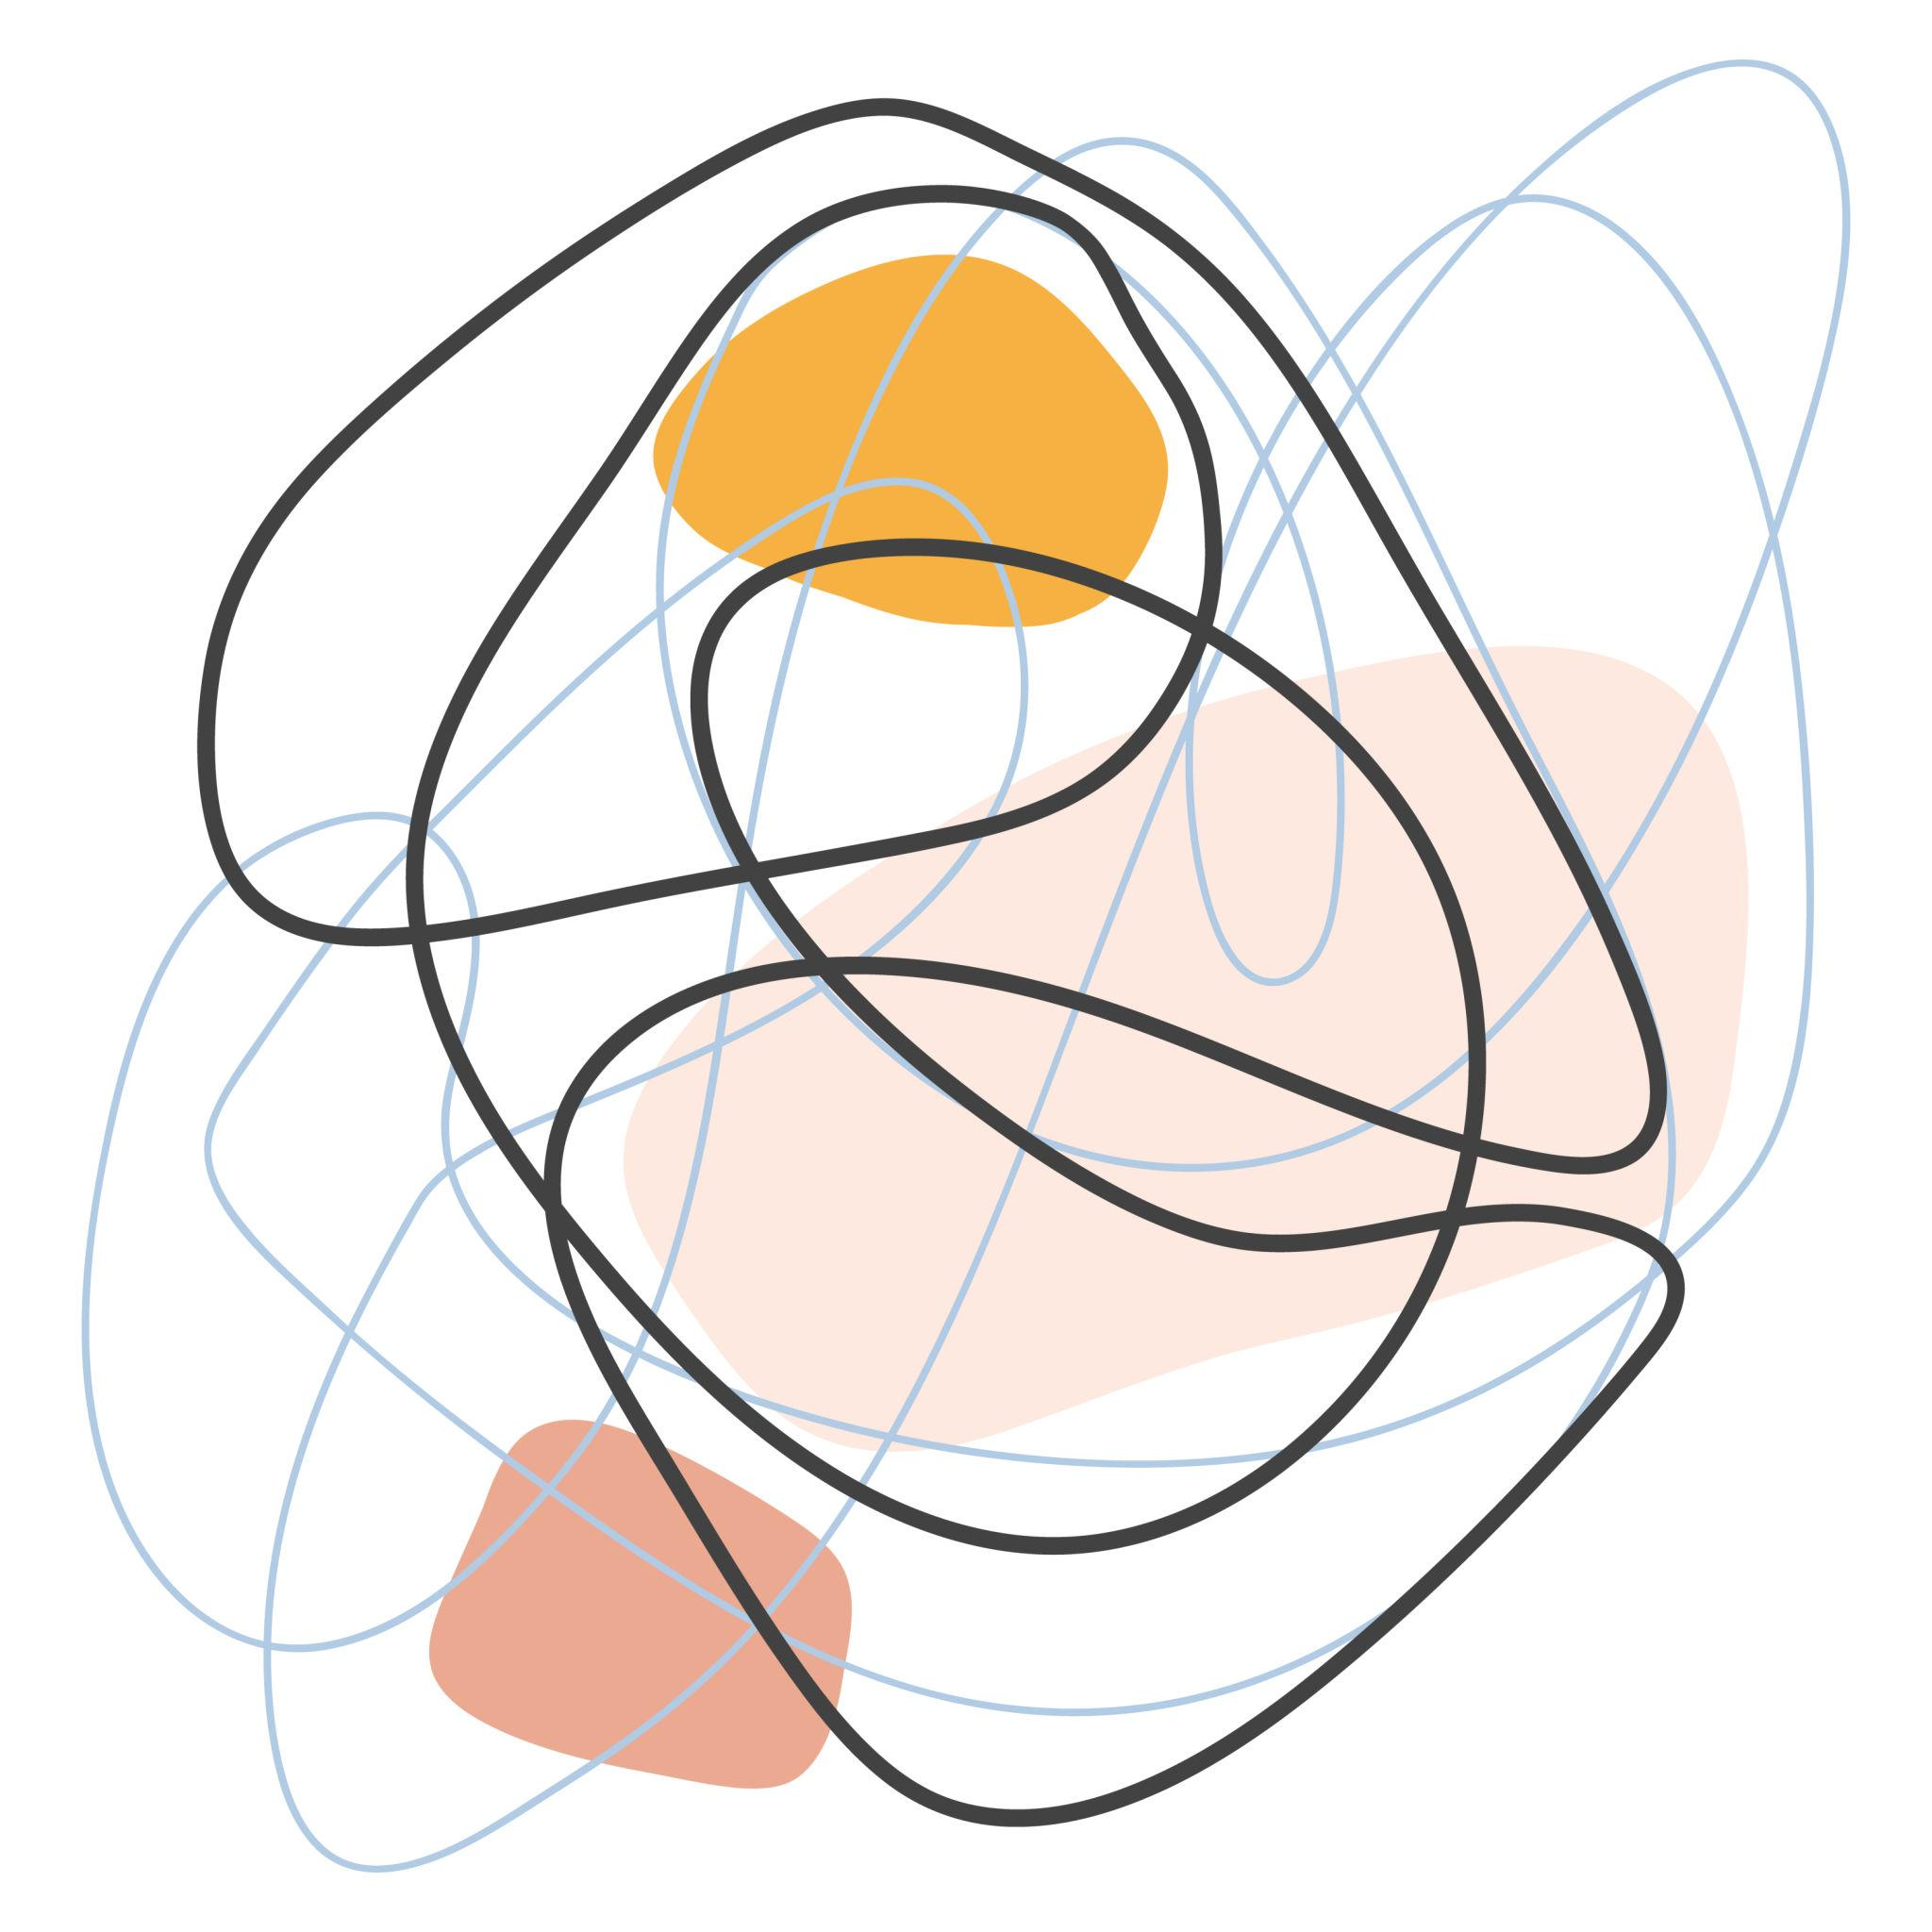
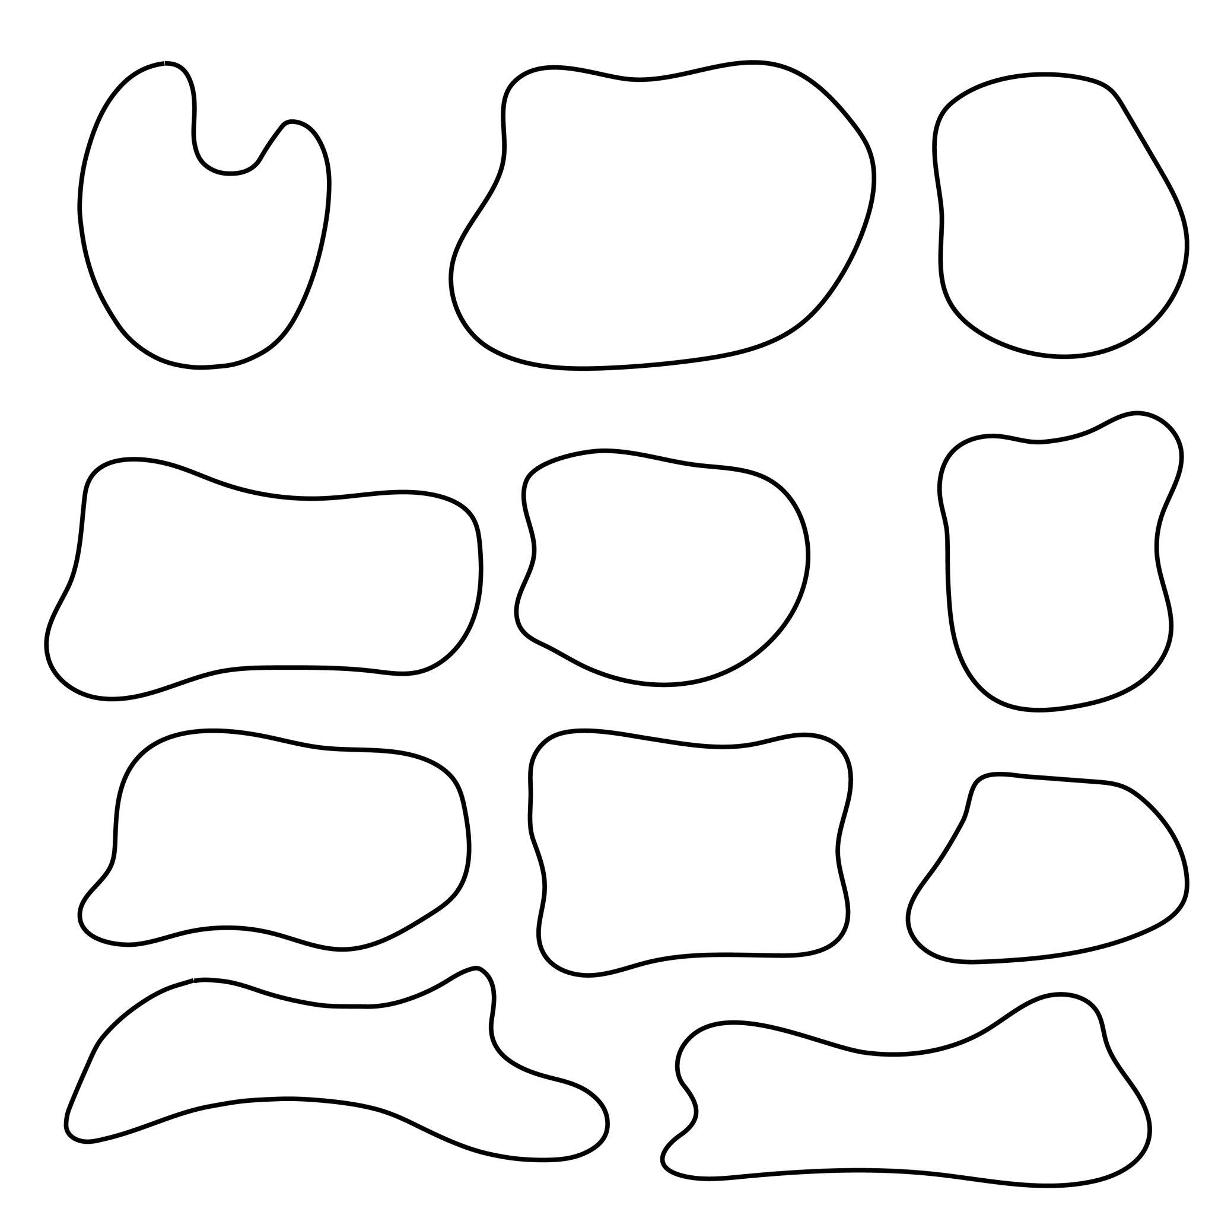
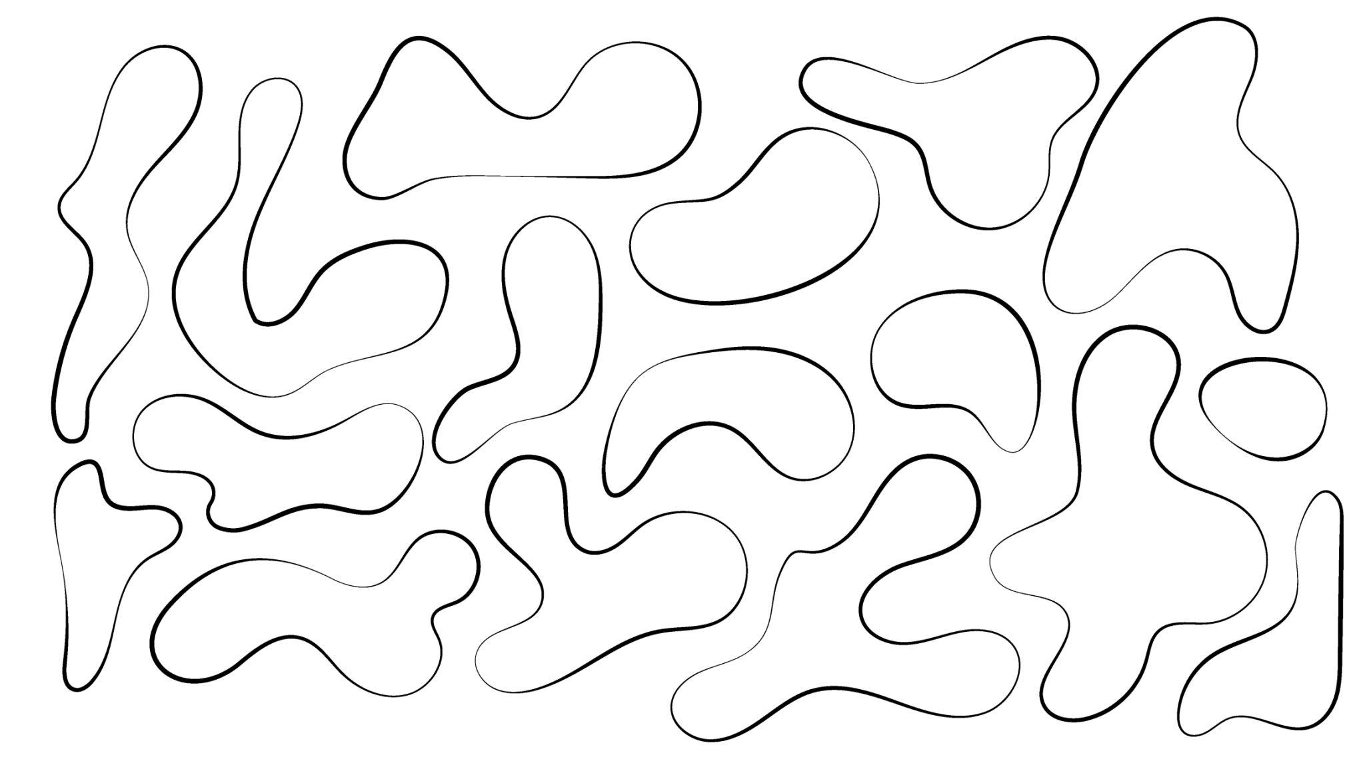
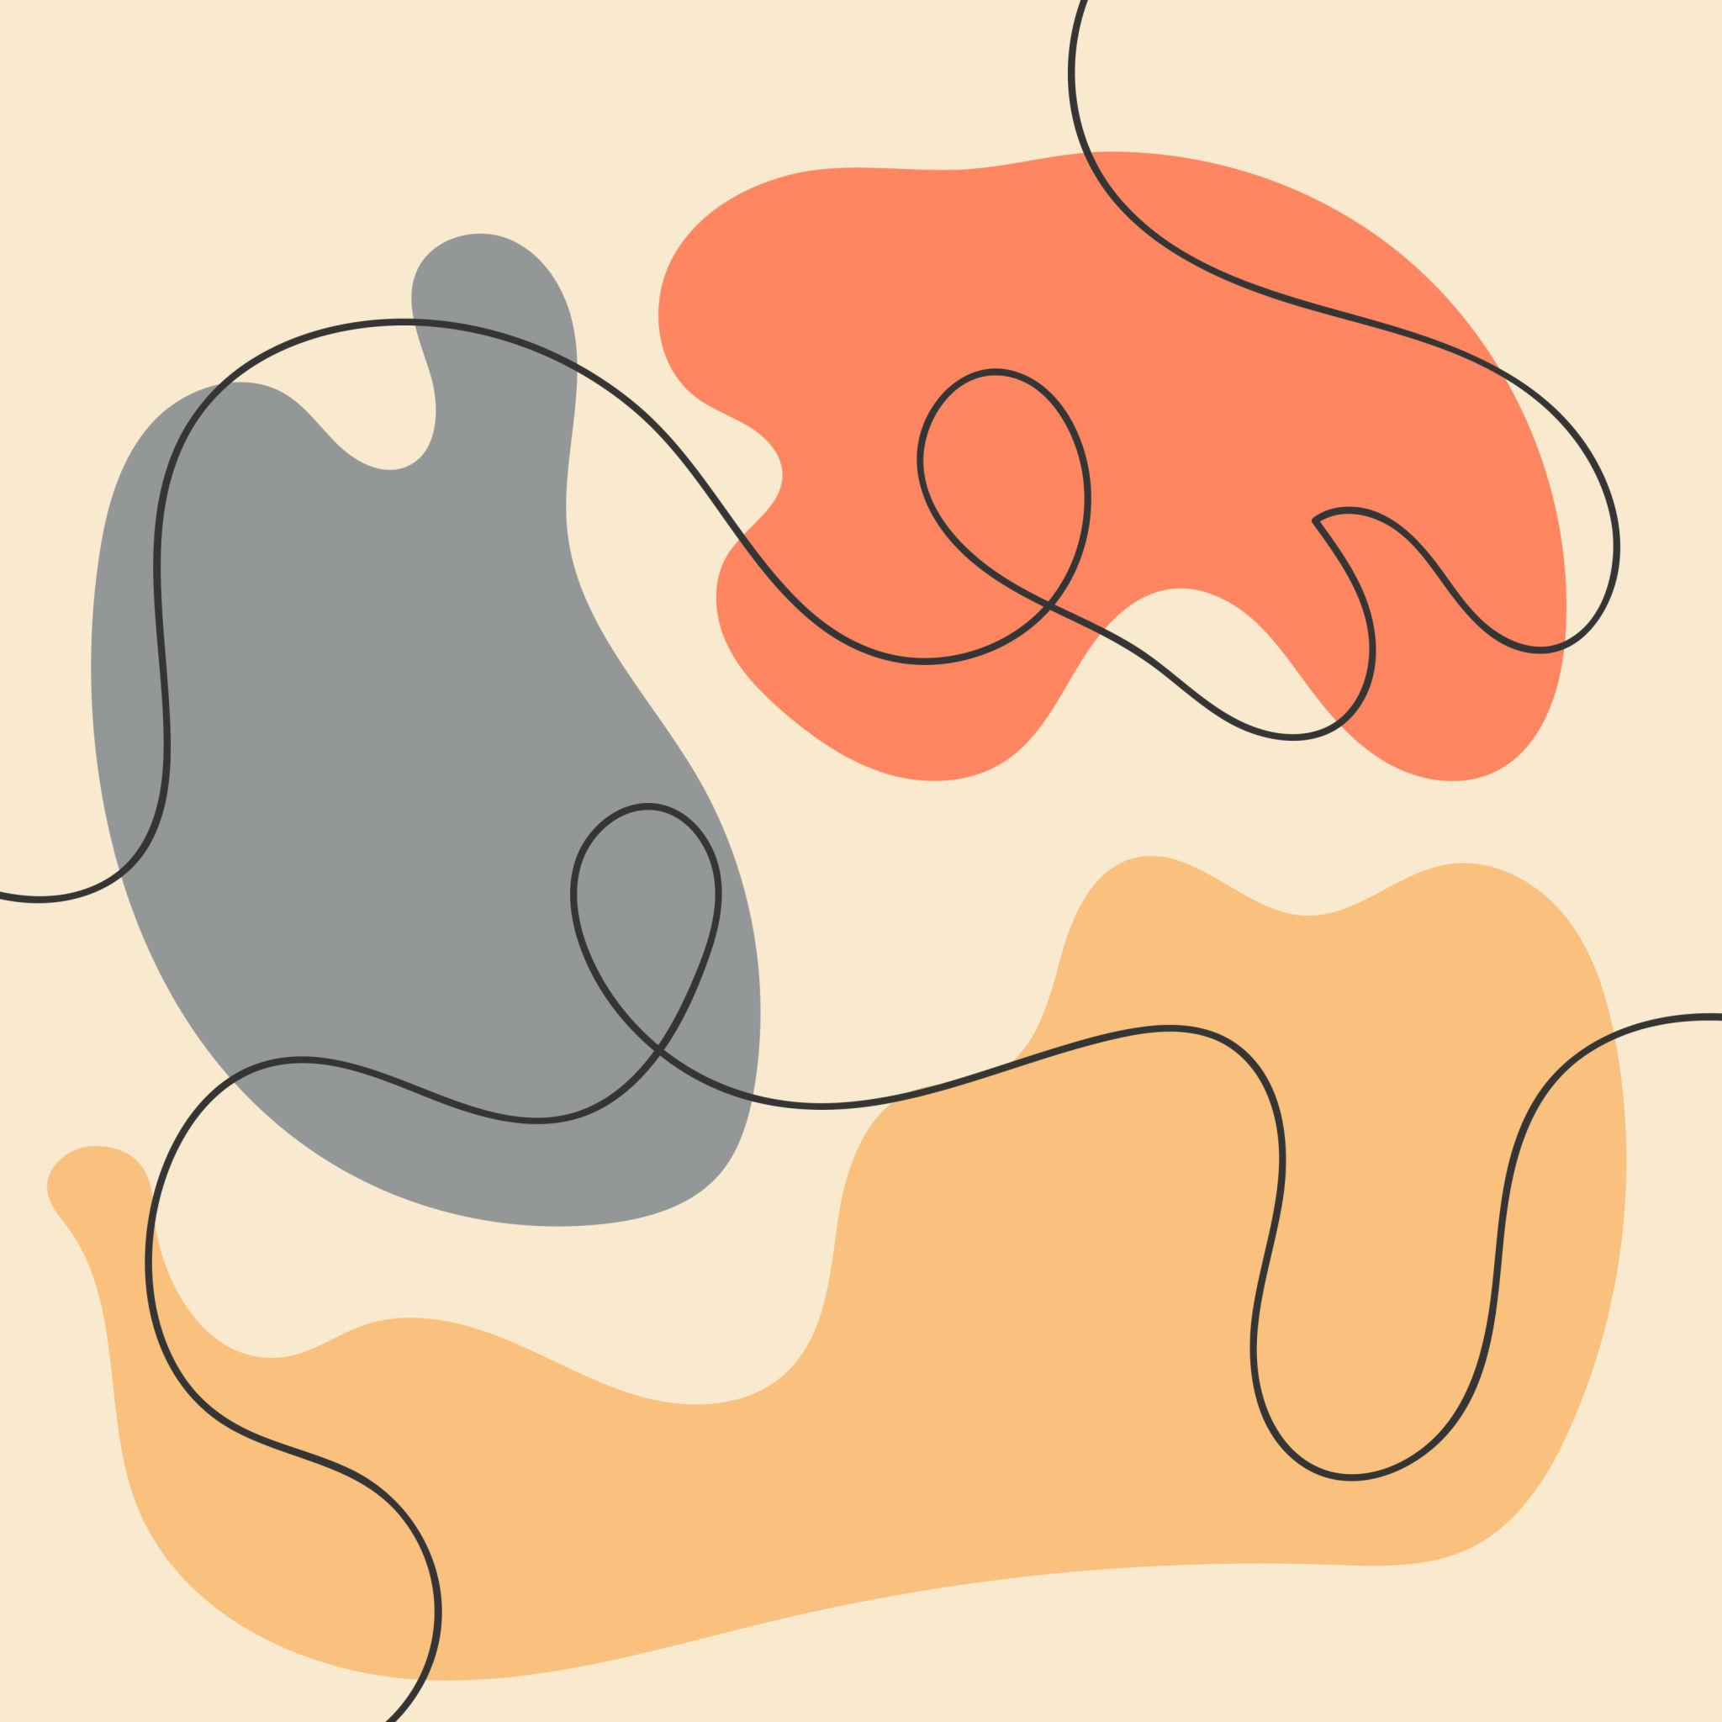

Definition
# Source: AI Source: Provided by: [Data Path: Persons Table -> ID Column: 1, Name_En Column: Motasem Essam] -> From: [ChatGPT] on [7/25/2026]
Freeform Curvilinear Shapes are shapes whose boundaries are formed primarily by curves that do not follow a fixed standard geometric form or predetermined regular pattern.
They can have arbitrary combinations of:
- curved directions
- varying curvature
- different curve sizes
- irregular proportions
- smooth transitions
- multiple types of curves
Unlike circles and ellipses, freeform curvilinear shapes do not generally have one fixed standard equation or geometric construction.

Fundamental Concept
# Source: AI Source: Provided by: [Data Path: Persons Table -> ID Column: 1, Name_En Column: Motasem Essam] -> From: [ChatGPT] on [7/25/2026]
The defining concept is the combination of:
$$\boxed{\text{Curvilinear}+\text{Freeform}}$$
Curvilinear means the shape is primarily formed by curves.
Freeform means the curves are not restricted to a standard geometric form such as a circle, ellipse, or parabola.
A freeform curve can be represented parametrically as:
$$\boxed{r\left(t\right)=\left(x , \left(t\right)y\left(t\right)\right)}$$
where x(t) and y(t) determine the shape of the curve.

Main Characteristics
# Source: AI Source: Provided by: [Data Path: Persons Table -> ID Column: 1, Name_En Column: Motasem Essam] -> From: [ChatGPT] on [7/25/2026]
Freeform curvilinear shapes commonly have:
- curved boundaries
- no fixed standard geometric form
- variable curvature
- irregular proportions
- flexible dimensions
- smooth or piecewise-smooth curves
- open or closed forms
- possible symmetry or asymmetry
- potentially multiple curve types
- potentially organic or abstract appearances
The absence of a standard geometric form is the key feature.

Types of Freeform Curvilinear Shapes
# Source: AI Source: Provided by: [Data Path: Persons Table -> ID Column: 1, Name_En Column: Motasem Essam] -> From: [ChatGPT] on [7/25/2026]
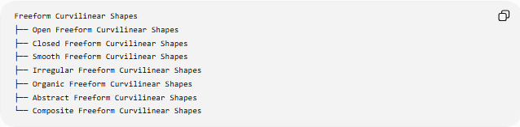
Freeform Curvilinear Shapes
├── Open Freeform Curvilinear Shapes
├── Closed Freeform Curvilinear Shapes
├── Smooth Freeform Curvilinear Shapes
├── Irregular Freeform Curvilinear Shapes
├── Organic Freeform Curvilinear Shapes
├── Abstract Freeform Curvilinear Shapes
└── Composite Freeform Curvilinear Shapes
These classifications are primarily descriptive rather than a universally standardized mathematical taxonomy.

Open Freeform Curvilinear Shapes
# Source: AI Source: Provided by: [Data Path: Persons Table -> ID Column: 1, Name_En Column: Motasem Essam] -> From: [ChatGPT] on [7/25/2026]
An Open Freeform Curvilinear Shape consists of a freeform curved path with endpoints.
For a parametric curve:
$$r\left(t\right)=\left(x , \left(t\right)y\left(t\right)\right)$$
an open curve generally satisfies:
$$\boxed{r\left(a\right)≠r\left(b\right)}$$
Example:
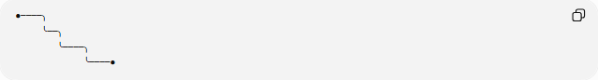
●────╮
╰──╮
╰────╮
╰────●
It does not enclose a region by itself.
Examples
- freeform curved paths
- decorative curved lines
- arbitrary Bézier curves
- flowing open curves

Closed Freeform Curvilinear Shapes
# Source: AI Source: Provided by: [Data Path: Persons Table -> ID Column: 1, Name_En Column: Motasem Essam] -> From: [ChatGPT] on [7/25/2026]
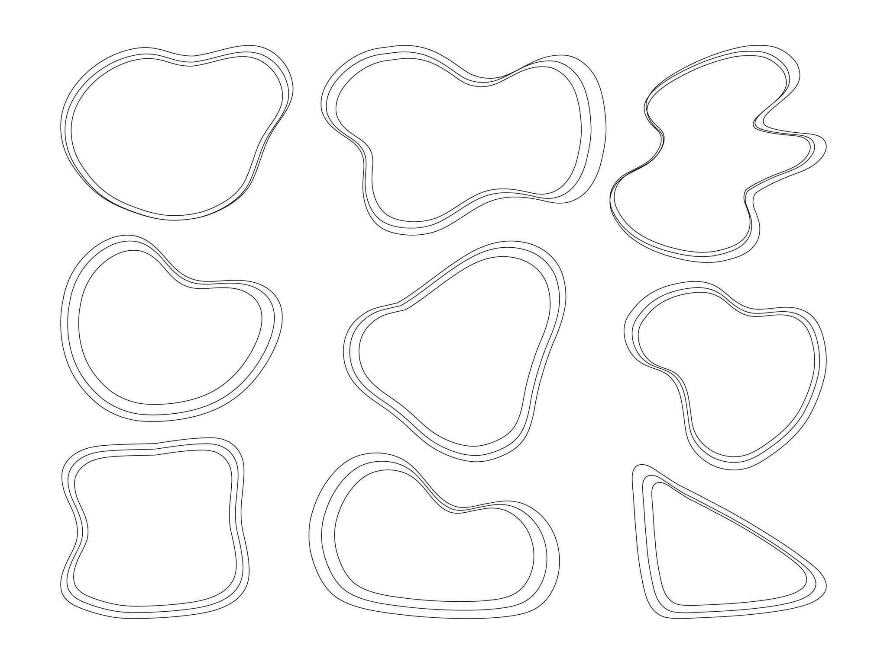
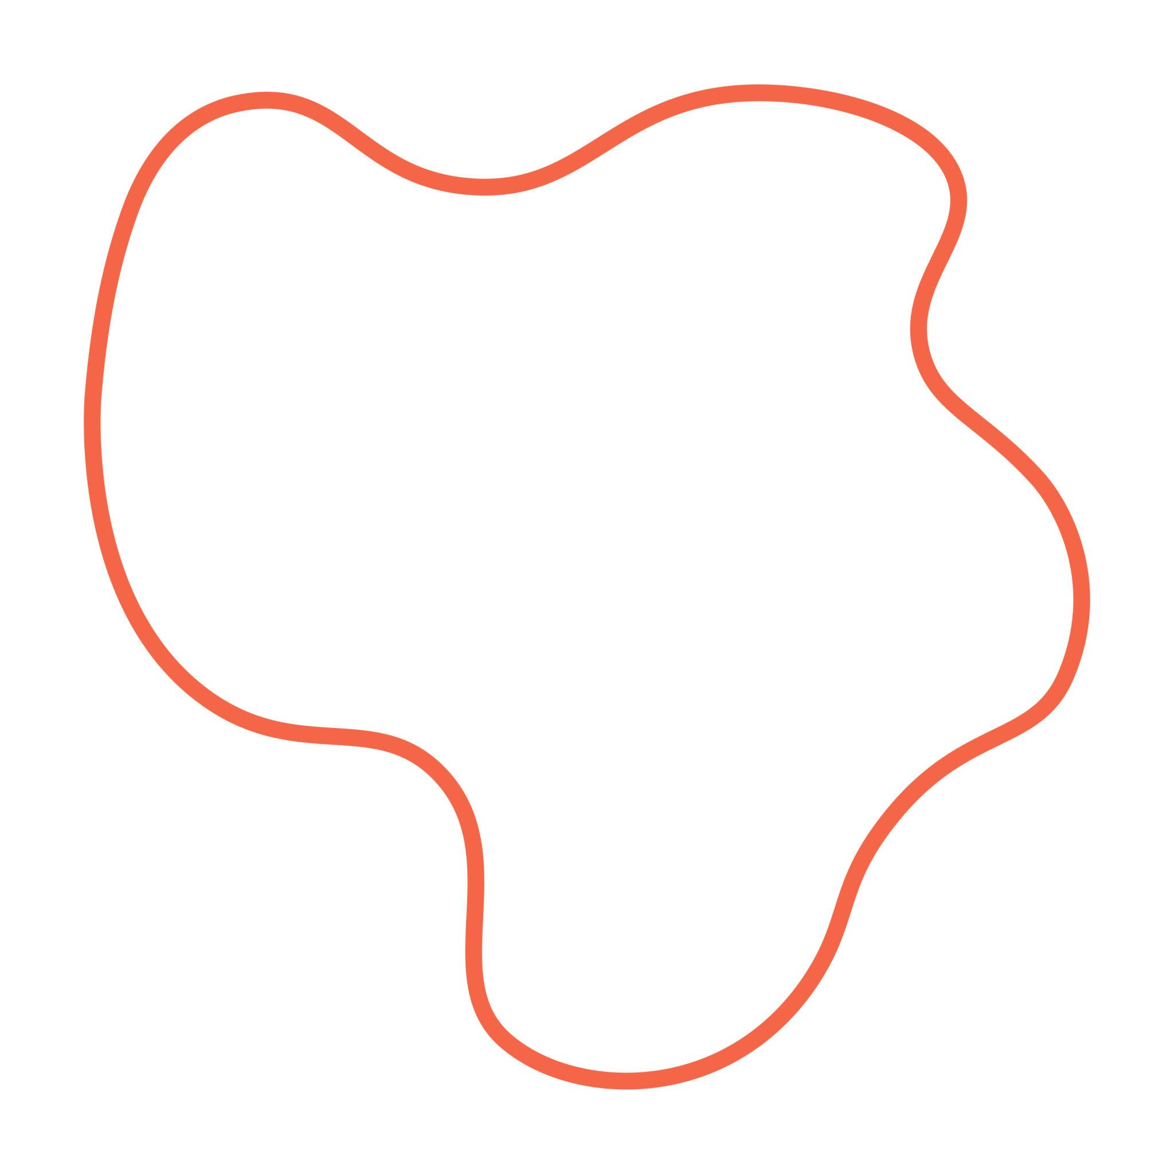
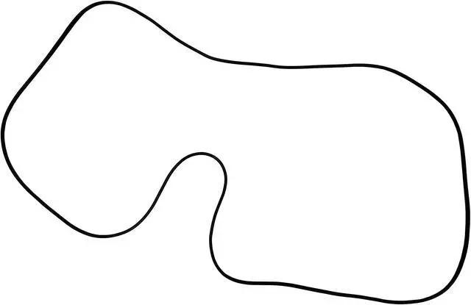
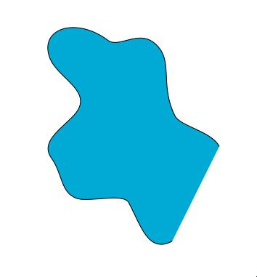
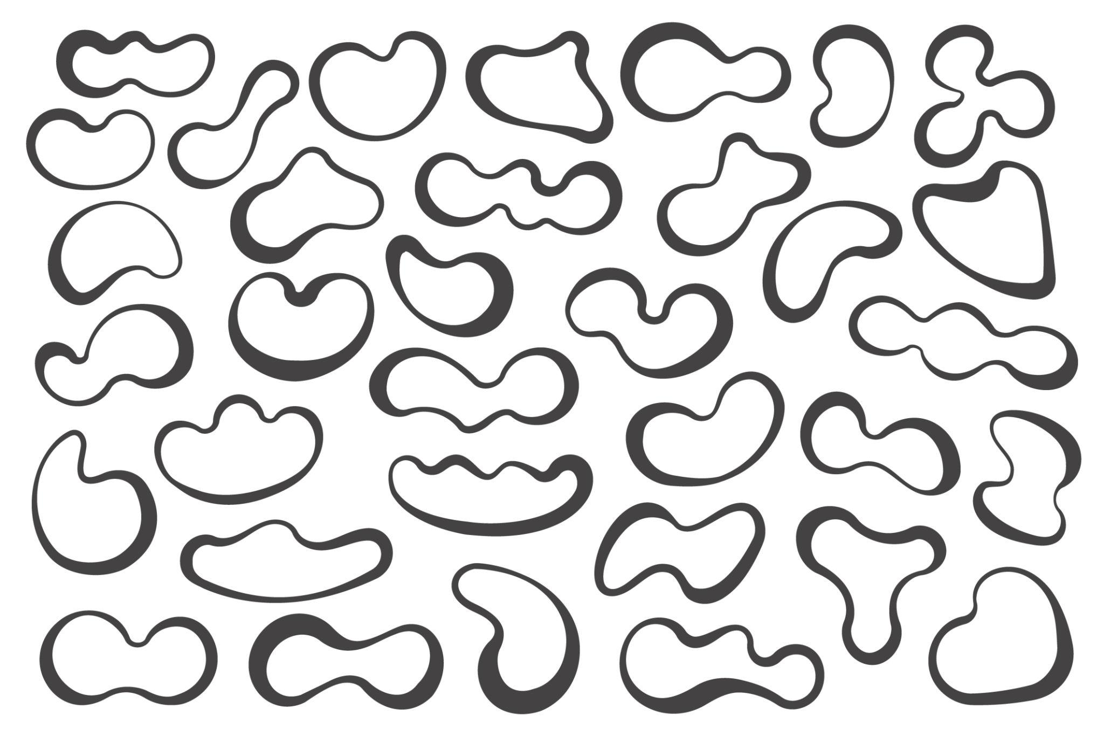
A Closed Freeform Curvilinear Shape is formed by a continuous curved boundary that returns to its starting point.
For a parametric curve:
$$\boxed{r\left(a\right)=r\left(b\right)}$$
A simple closed freeform curve encloses a region.
Examples include:
- irregular blob-like shapes
- organic outlines
- abstract closed curves
- custom decorative shapes

Smooth Freeform Curvilinear Shapes
# Source: AI Source: Provided by: [Data Path: Persons Table -> ID Column: 1, Name_En Column: Motasem Essam] -> From: [ChatGPT] on [7/25/2026]
A Smooth Freeform Curvilinear Shape uses curves that change direction continuously without sharp corners along the relevant boundary.
For:
$$y=f\left(x\right)$$
the curve is smooth where its derivative exists and behaves continuously.
A stronger smoothness condition can be expressed as:
$$f∈C^{1}$$
meaning that both the function and its first derivative are continuous.
Smooth freeform shapes are common in:
- industrial design
- computer graphics
- typography
- product design
- architecture

Irregular Freeform Curvilinear Shapes
# Source: AI Source: Provided by: [Data Path: Persons Table -> ID Column: 1, Name_En Column: Motasem Essam] -> From: [ChatGPT] on [7/25/2026]
An Irregular Freeform Curvilinear Shape has no uniform or repeating geometric pattern.
Its:
- curvature may vary
- widths may vary
- bends may vary
- proportions may vary
- local features may differ
Example:
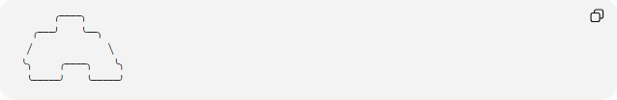
╭────╮
╭───╯ ╰──╮
╱ ╲
╰╮ ╭────╮ ╰╮
╰─────╯ ╰─────╯
Important distinction
$$\boxed{\text{Freeform}≠\text{Irregular}}$$
Freeform describes the absence of a fixed geometric form.
Irregular describes a lack of uniformity or regular pattern.
A shape can therefore be freeform but intentionally regular-looking, or irregular without being freeform.

Organic Freeform Curvilinear Shapes
# Source: AI Source: Provided by: [Data Path: Persons Table -> ID Column: 1, Name_En Column: Motasem Essam] -> From: [ChatGPT] on [7/25/2026]
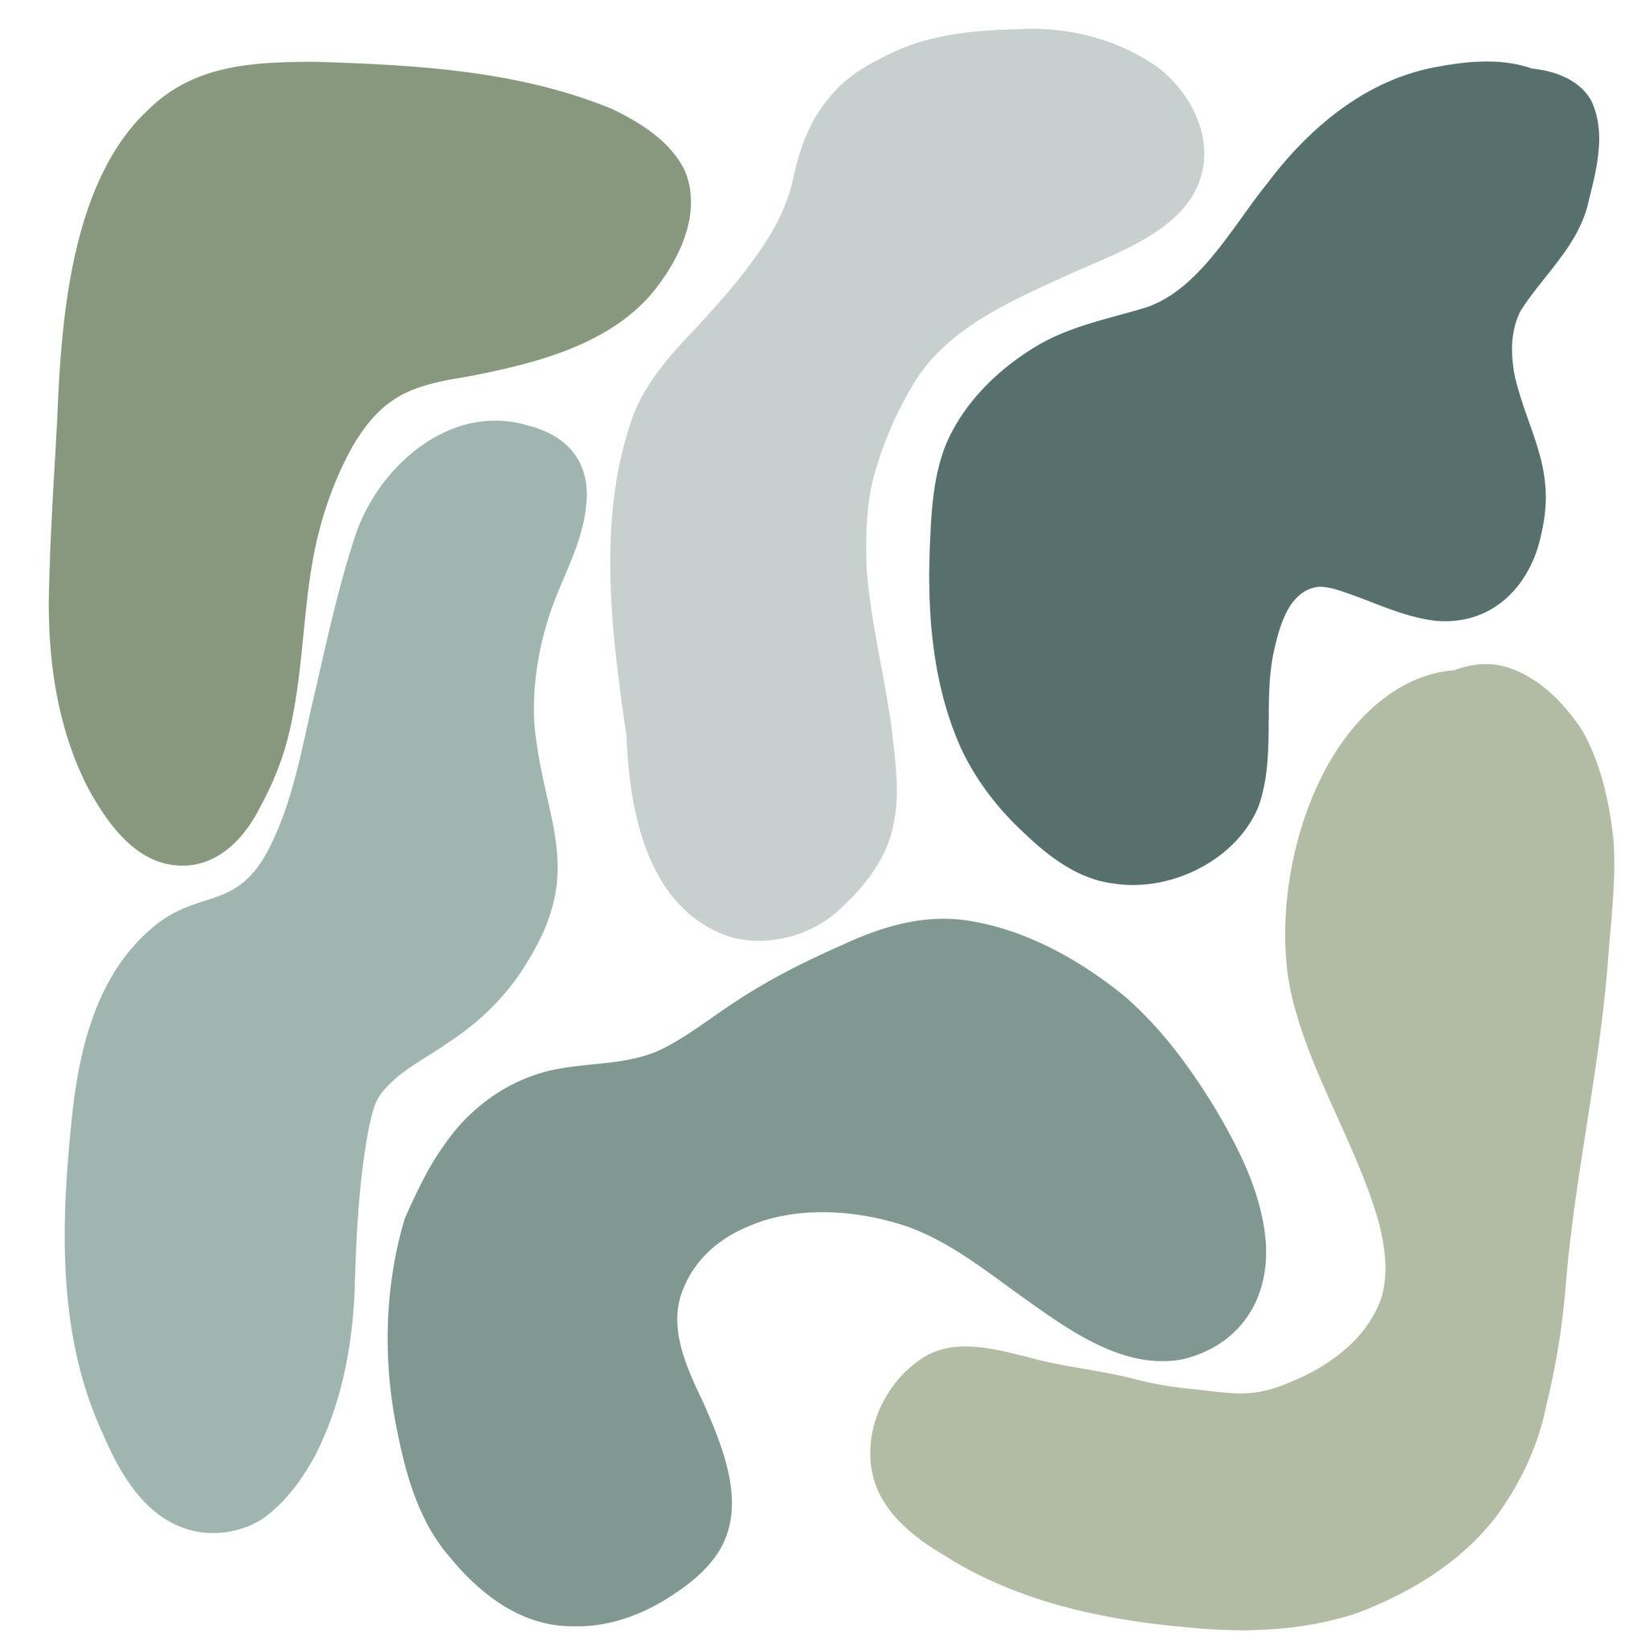
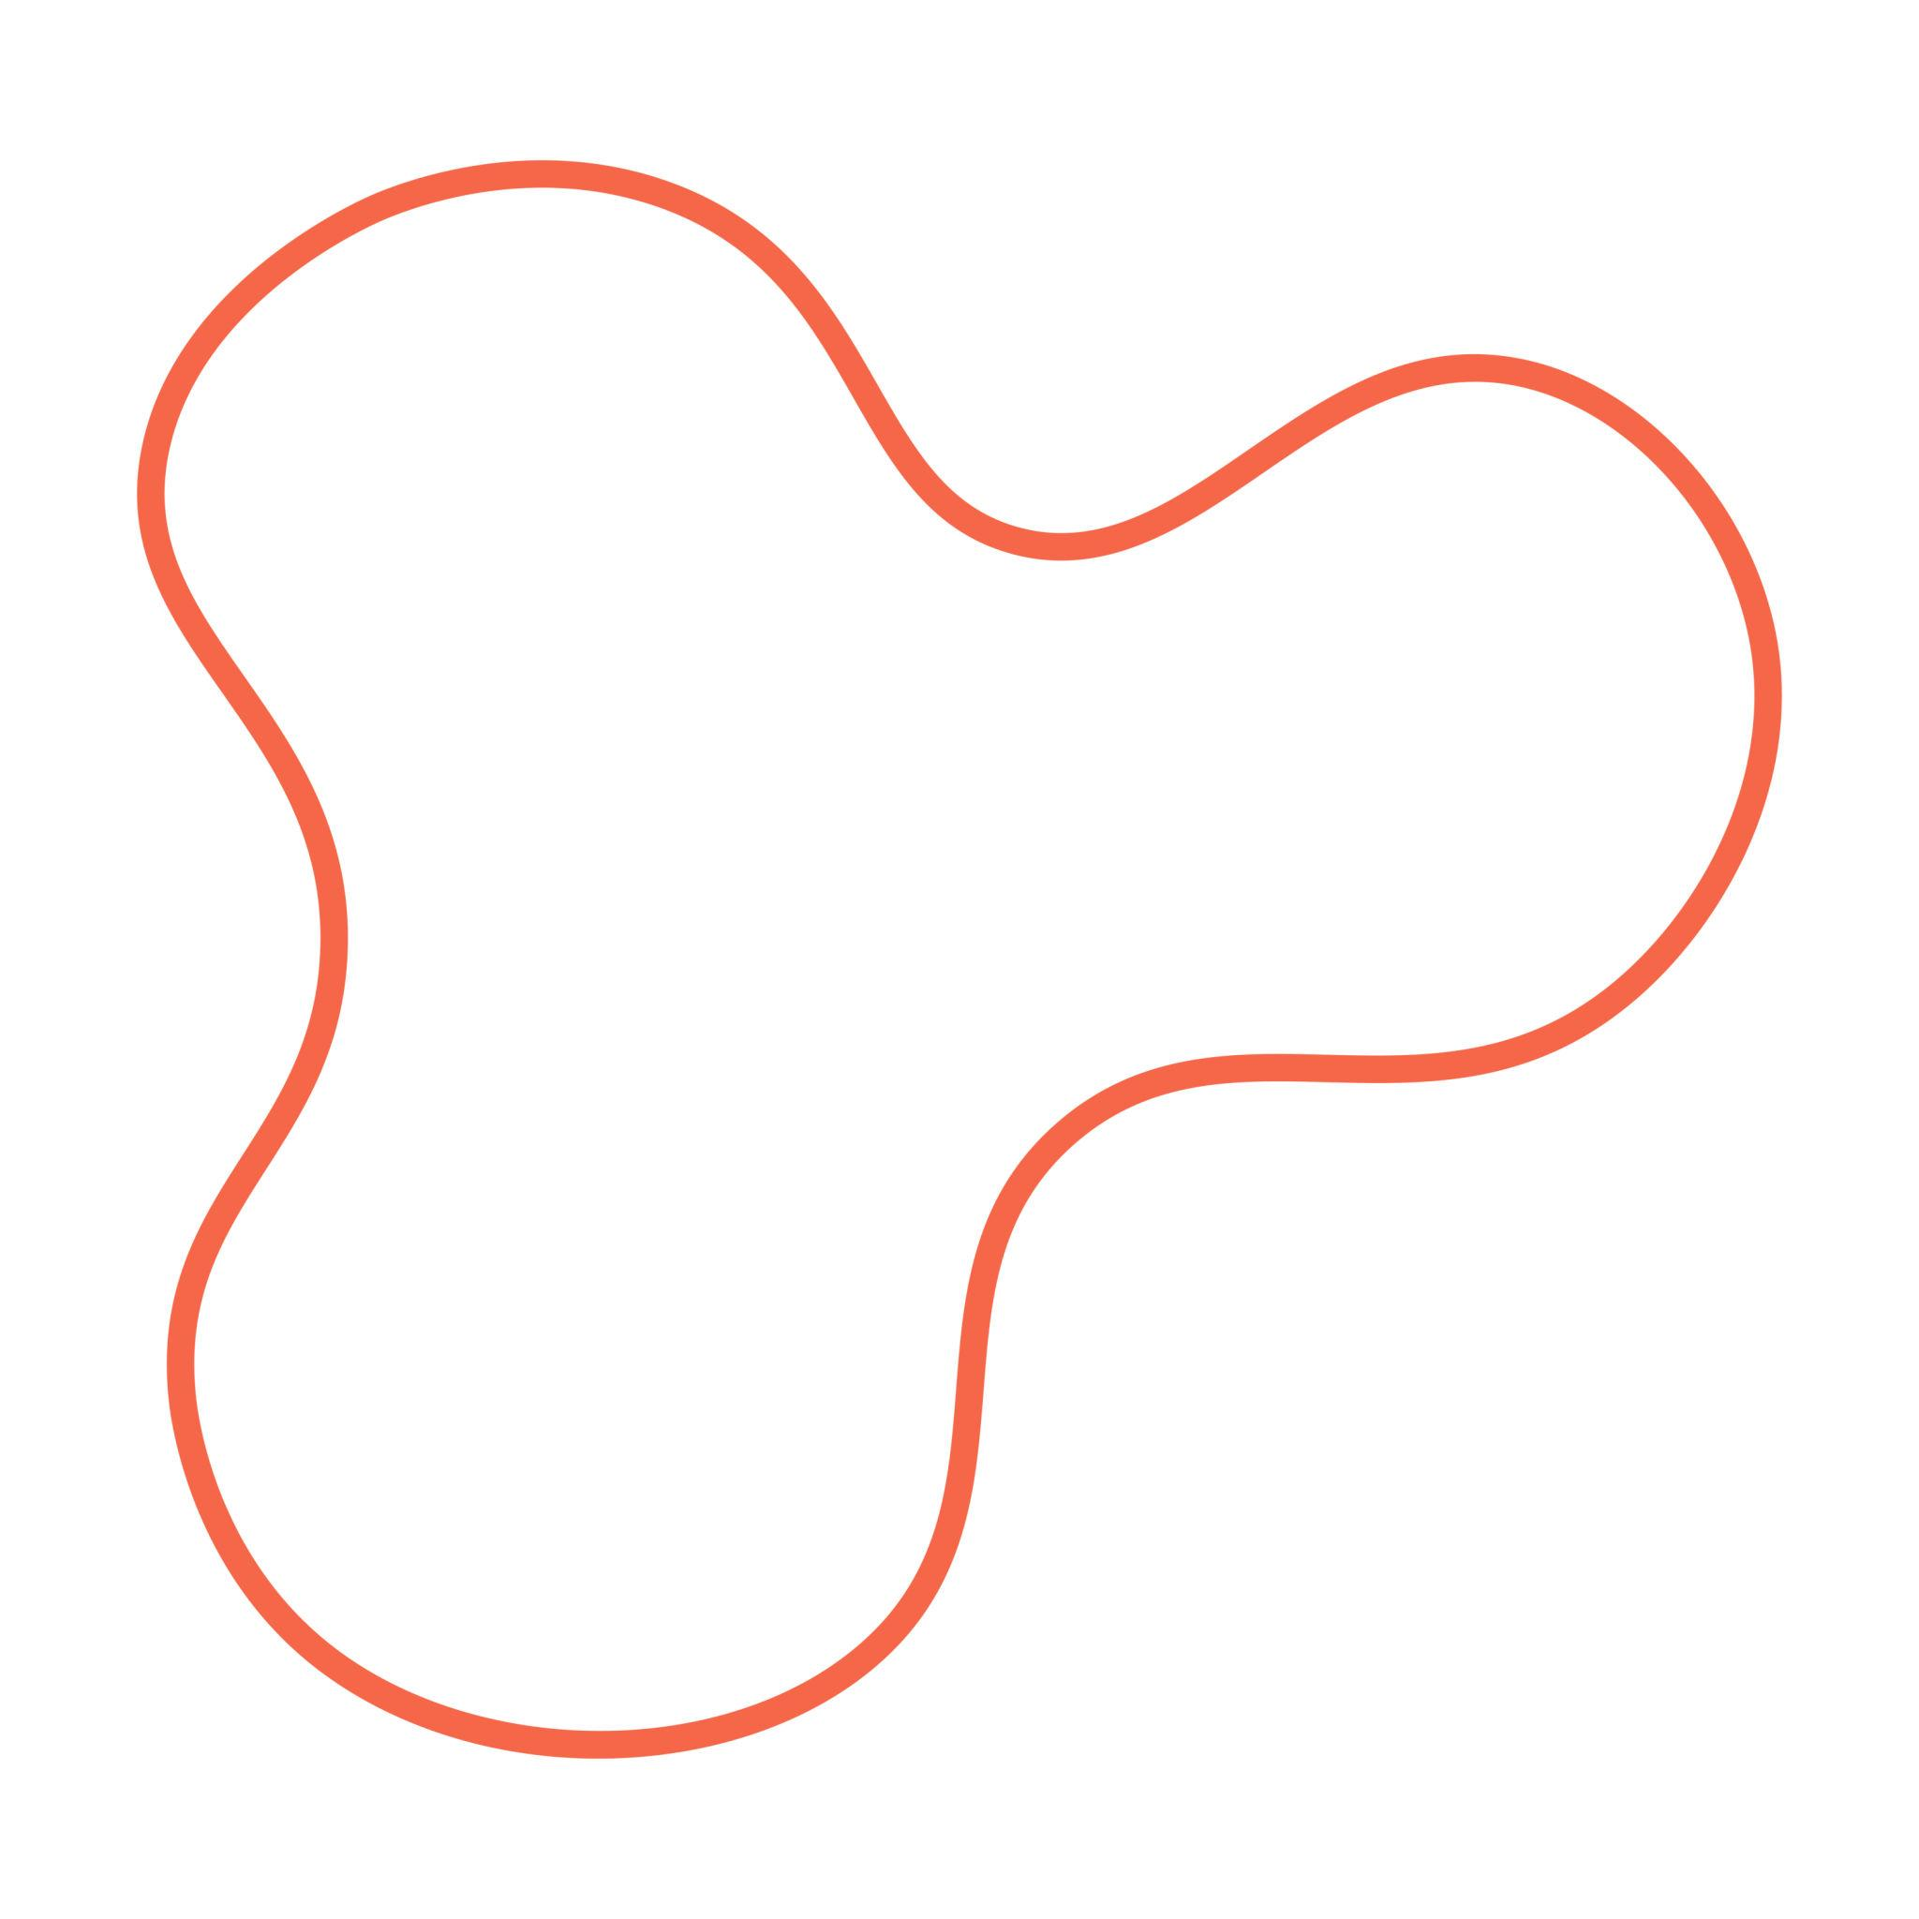
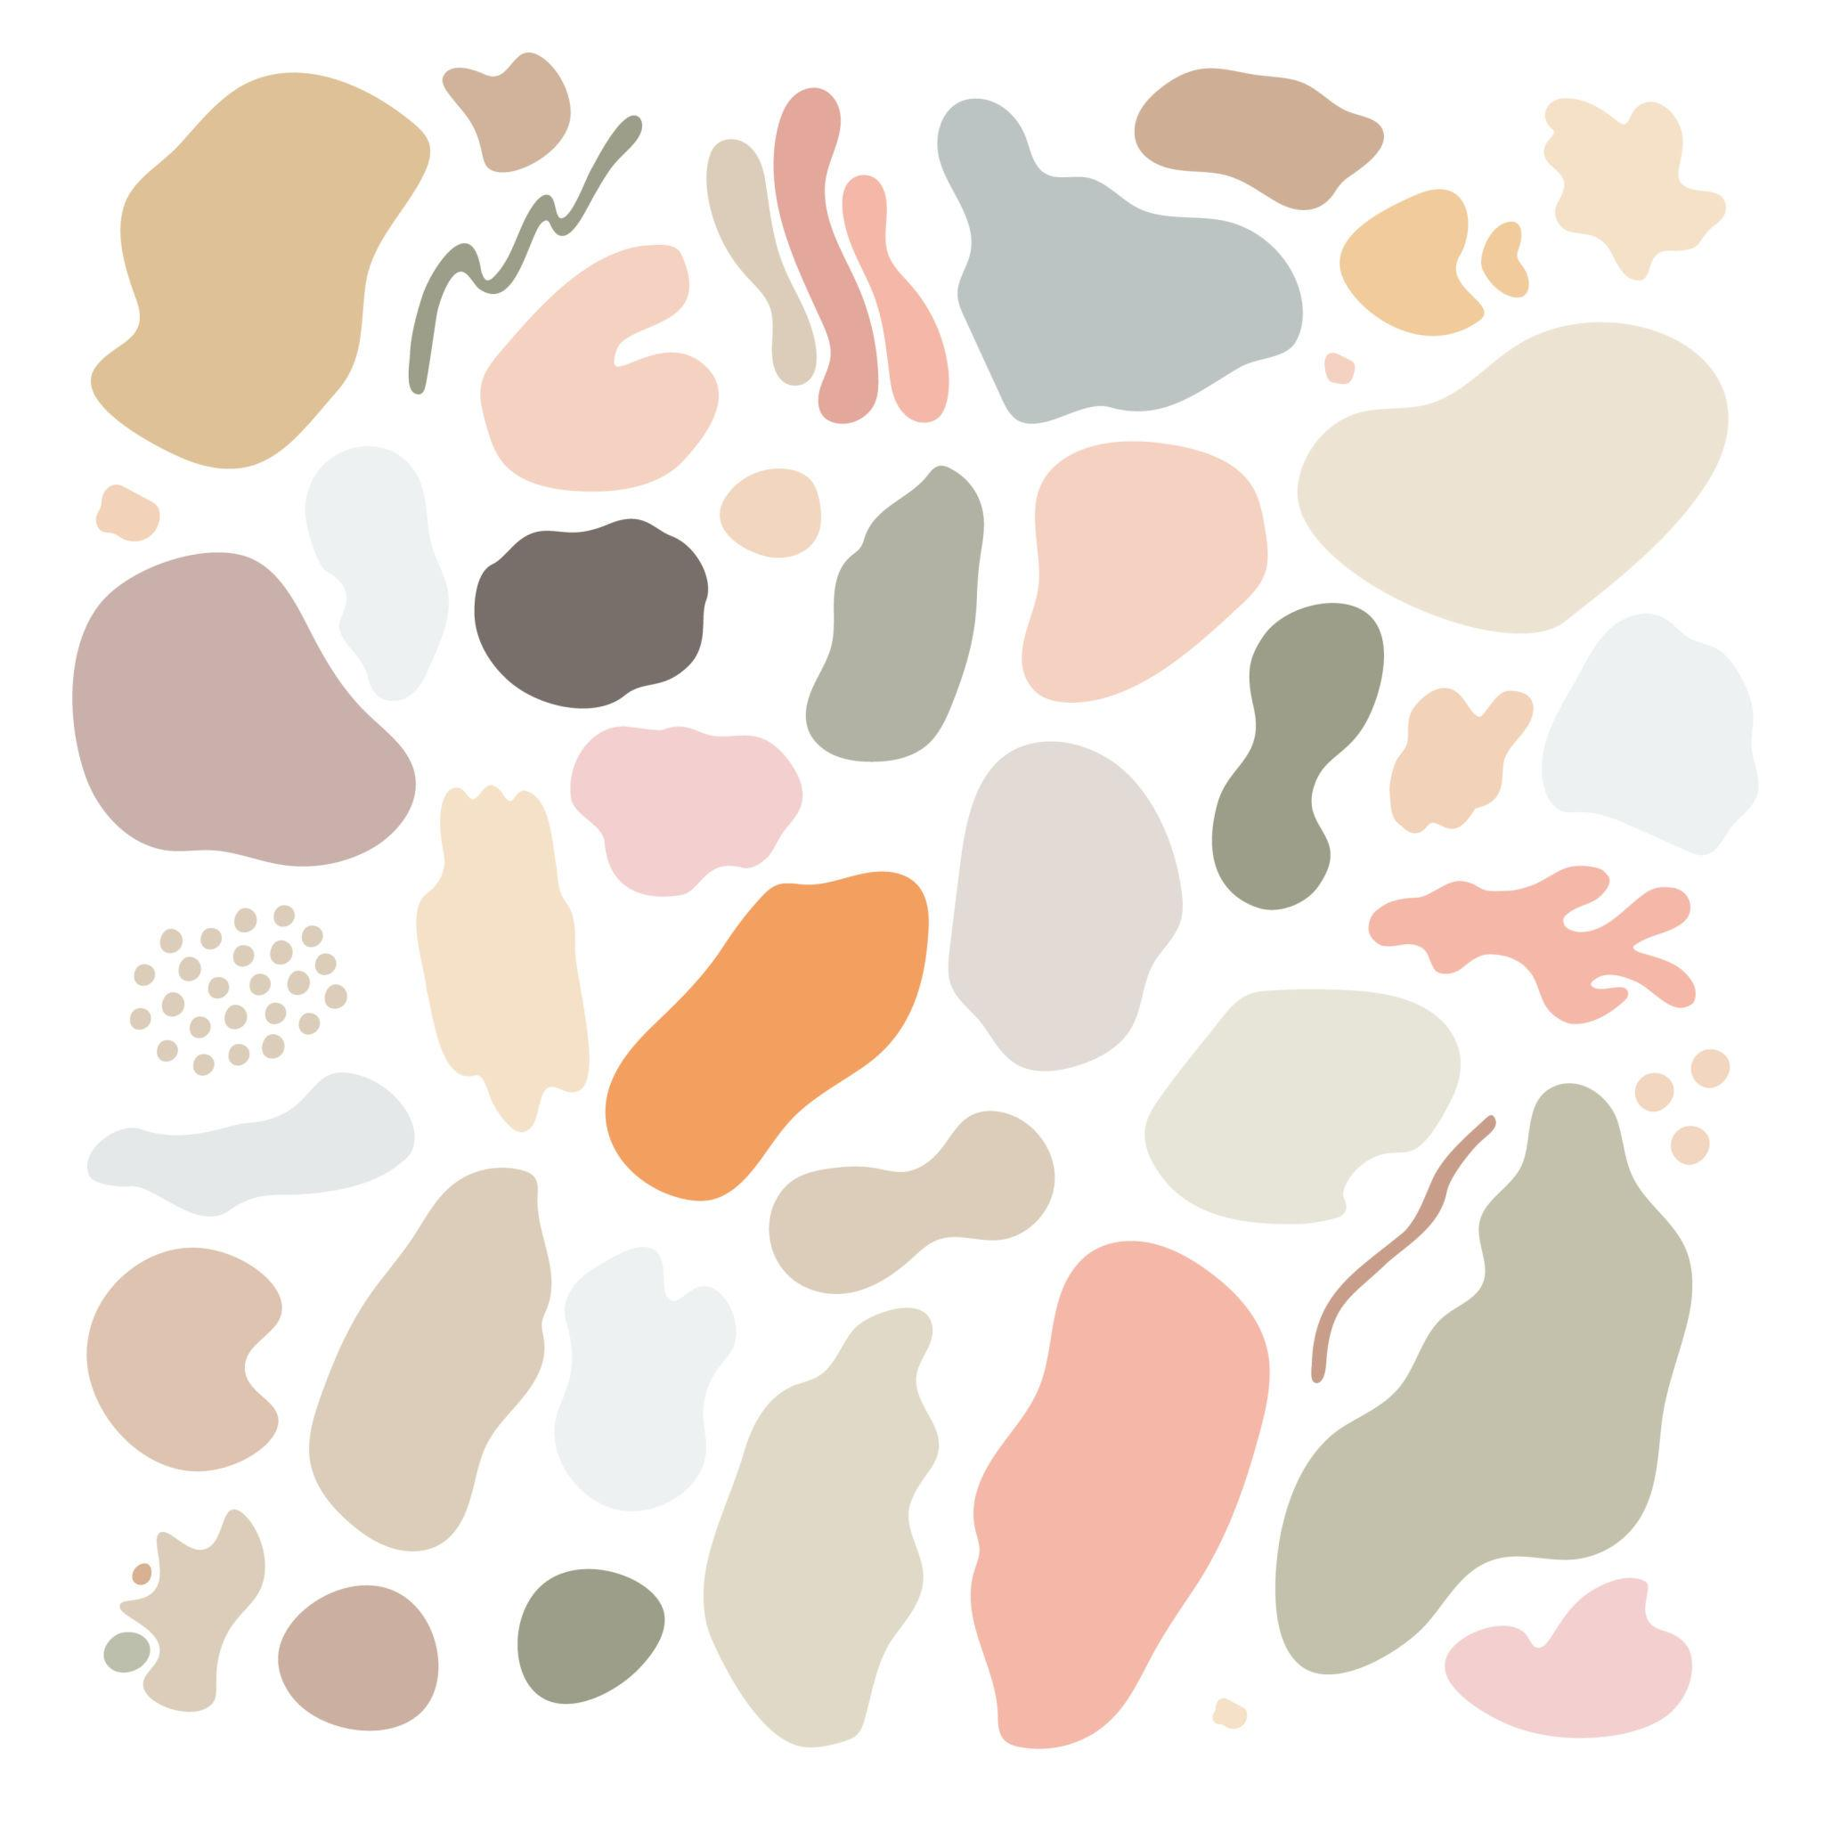
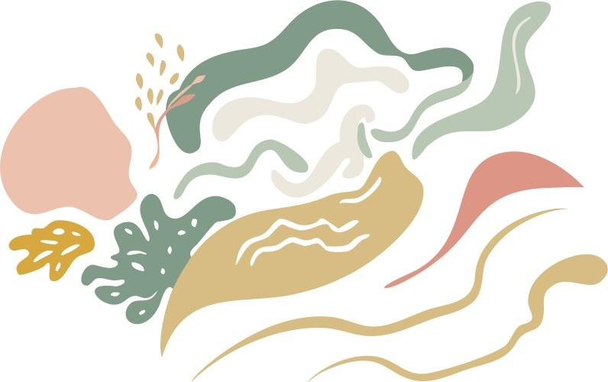
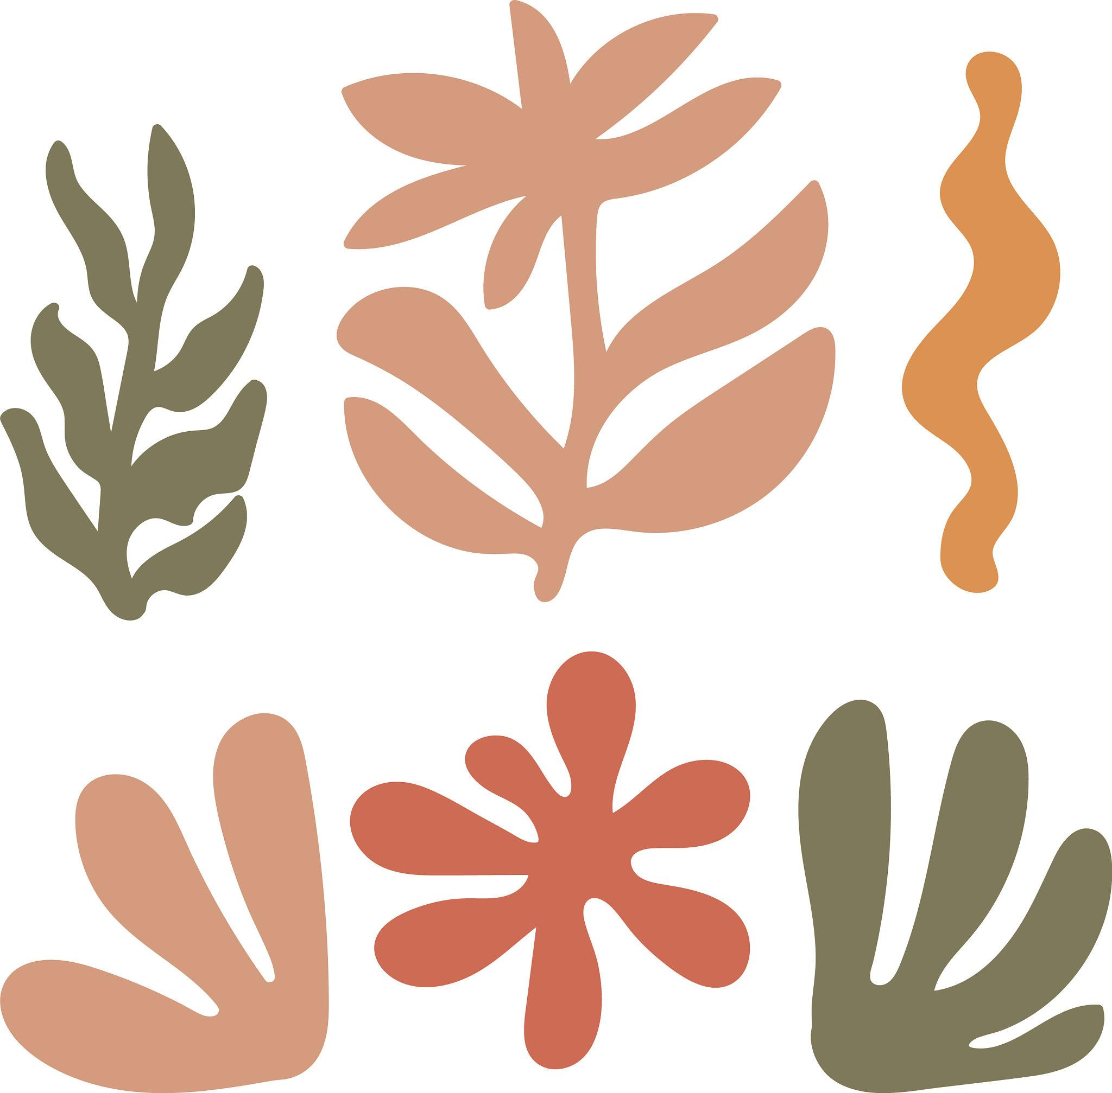
Organic Freeform Curvilinear Shapes are freeform curves with natural, flowing, or nature-inspired appearances.
Examples include shapes resembling:
- leaves
- clouds
- petals
- water
- flames
- natural biological forms
They generally avoid rigid geometric construction.
Important distinction
Organic emphasizes the natural or flowing character.
Freeform emphasizes the absence of a fixed geometric form.
Therefore, an organic shape can also be freeform.

Abstract Freeform Curvilinear Shapes
# Source: AI Source: Provided by: [Data Path: Persons Table -> ID Column: 1, Name_En Column: Motasem Essam] -> From: [ChatGPT] on [7/25/2026]
An Abstract Freeform Curvilinear Shape is a non-standard curved form that does not necessarily represent a recognizable real-world object.
It may be designed using:
- arbitrary curves
- Bézier curves
- splines
- mathematical functions
- artistic constructions
Example:
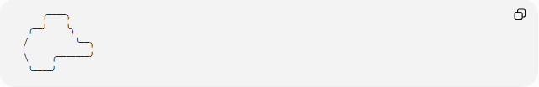
╭────╮
╭──╯ ╰╮
╱ ╰──╮
╲ ╭───────╯
╰────╯
Its defining characteristic is its non-standard abstract form.

Composite Freeform Curvilinear Shapes
# Source: AI Source: Provided by: [Data Path: Persons Table -> ID Column: 1, Name_En Column: Motasem Essam] -> From: [ChatGPT] on [7/25/2026]
A Composite Freeform Curvilinear Shape combines multiple freeform curves into one overall shape.
The components may have:
- different curvature
- different radii
- different orientations
- different mathematical descriptions
- different levels of smoothness
A piecewise representation can be written as:
$$r\left(t\right)=\left\{\begin{matrix}r_{1}\left(t\right), & t_{0}≤t<c \\ r_{2}\left(t\right), & c≤t≤t_{1}\end{matrix}\right.$$
For a continuous connection:
$$\boxed{r_{1}\left(c\right)=r_{2}\left(c\right)}$$
For tangent continuity:
$$r_{1}^{'}\left(c\right)∥r_{2}^{'}\left(c\right)$$

Mathematical Representation
# Source: AI Source: Provided by: [Data Path: Persons Table -> ID Column: 1, Name_En Column: Motasem Essam] -> From: [ChatGPT] on [7/25/2026]
Freeform curves can be represented in several ways.
Cartesian Form
$$\boxed{y=f\left(x\right)}$$
Useful when one y value corresponds to each x value.
Parametric Form
$$\boxed{x=x\left(t\right), y=y\left(t\right)}$$
This is more flexible and can represent curves that cannot easily be written as y=f(x).
Polar Form
$$\boxed{r=f\left(θ\right)}$$
Useful for curves described relative to a central point.

Bézier Curves
# Source: AI Source: Provided by: [Data Path: Persons Table -> ID Column: 1, Name_En Column: Motasem Essam] -> From: [ChatGPT] on [7/25/2026]
Bézier curves are widely used to construct freeform curved shapes.
A cubic Bézier curve is:
$$\boxed{B\left(t\right)={\left(1-t\right)}^{3}P_{0}+3{\left(1-t\right)}^{2}tP_{1}+3\left(1-t\right)t^{2}P_{2}+t^{3}P_{3}}$$
where:
$$0≤t≤1$$
The points are:
- P₀ → starting point
- P₁ → first control point
- P₂ → second control point
- P₃ → ending point
Bézier curves allow the boundary to be shaped without requiring a standard geometric equation.

Curvature
# Source: AI Source: Provided by: [Data Path: Persons Table -> ID Column: 1, Name_En Column: Motasem Essam] -> From: [ChatGPT] on [7/25/2026]
For a graph:
$$y=f\left(x\right)$$
the curvature is:
$$\boxed{κ=\frac{∣f^{''}\left(x\right)∣}{{\left(1+{\left[f^{'}\left(x\right)\right]}^{2}\right)}^{3/2}}}$$
Freeform curves generally have variable curvature.
Different portions of the boundary may bend more or less strongly.
This distinguishes them from a circle, where:
$$κ=\frac{1}{r}$$
is constant.

Arc Length
# Source: AI Source: Provided by: [Data Path: Persons Table -> ID Column: 1, Name_En Column: Motasem Essam] -> From: [ChatGPT] on [7/25/2026]
For a freeform curve:
$$y=f\left(x\right)$$
the arc length between x=a and x=b is:
$$\boxed{L=\int_{a}^{b}{\sqrt{1+{\left[f^{'}\left(x\right)\right]}^{2}}} dx}$$
For a parametric curve:
$$x=x\left(t\right), y=y\left(t\right)$$
the arc length is:
$$\boxed{L=\int_{a}^{b}{\sqrt{{\left(\frac{dx}{dt}\right)}^{2}+{\left(\frac{dy}{dt}\right)}^{2}}} dt}$$

Area of a Closed Freeform Shape
# Source: AI Source: Provided by: [Data Path: Persons Table -> ID Column: 1, Name_En Column: Motasem Essam] -> From: [ChatGPT] on [7/25/2026]
For a simple closed parametric curve:
$$x=x\left(t\right), y=y\left(t\right)$$
the enclosed area can be calculated by:
$$\boxed{A=\frac{1}{2}\oint{(}\left.x dy-y dx\right)}$$
This is useful when the freeform boundary does not have a simple standard area formula.

Symmetry
# Source: AI Source: Provided by: [Data Path: Persons Table -> ID Column: 1, Name_En Column: Motasem Essam] -> From: [ChatGPT] on [7/25/2026]
Freeform does not mean asymmetric.
A freeform curvilinear shape can have:
- reflection symmetry
- rotational symmetry
- point symmetry
- no symmetry
For a reflection transformation T:
$$\boxed{T\left(S\right)=S}$$
indicates symmetry.
Thus, a custom freeform shape can be deliberately designed to be symmetric.

Freeform vs Circular Curvilinear Shapes
# Source: AI Source: Provided by: [Data Path: Persons Table -> ID Column: 1, Name_En Column: Motasem Essam] -> From: [ChatGPT] on [7/25/2026]
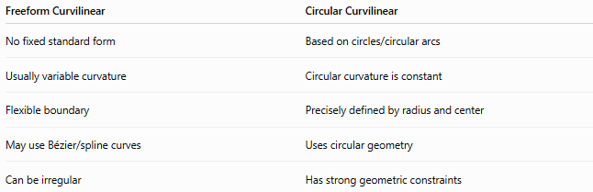
Freeform Curvilinear | Circular Curvilinear
No fixed standard form | Based on circles/circular arcs
Usually variable curvature | Circular curvature is constant
Flexible boundary | Precisely defined by radius and center
May use Bézier/spline curves | Uses circular geometry
Can be irregular | Has strong geometric constraints
For example:
$$\text{Circle}→\text{standard geometric curve}$$
while:
$$\text{Custom B}\overset{ˊ}{\text{e}}\text{zier boundary}→\text{freeform curve}$$

Freeform vs Elliptical Curvilinear Shapes
# Source: AI Source: Provided by: [Data Path: Persons Table -> ID Column: 1, Name_En Column: Motasem Essam] -> From: [ChatGPT] on [7/25/2026]
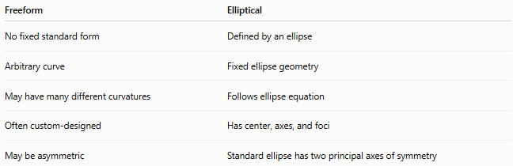
Freeform | Elliptical
No fixed standard form | Defined by an ellipse
Arbitrary curve | Fixed ellipse geometry
May have many different curvatures | Follows ellipse equation
Often custom-designed | Has center, axes, and foci
May be asymmetric | Standard ellipse has two principal axes of symmetry
An ellipse is therefore a curvilinear shape, but a standard ellipse is not freeform.

Freeform vs Wavy Curvilinear Shapes
# Source: AI Source: Provided by: [Data Path: Persons Table -> ID Column: 1, Name_En Column: Motasem Essam] -> From: [ChatGPT] on [7/25/2026]
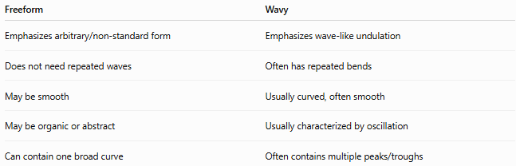
Freeform | Wavy
Emphasizes arbitrary/non-standard form | Emphasizes wave-like undulation
Does not need repeated waves | Often has repeated bends
May be smooth | Usually curved, often smooth
May be organic or abstract | Usually characterized by oscillation
Can contain one broad curve | Often contains multiple peaks/troughs
A shape can be both freeform and wavy.

Freeform vs Organic Shapes
# Source: AI Source: Provided by: [Data Path: Persons Table -> ID Column: 1, Name_En Column: Motasem Essam] -> From: [ChatGPT] on [7/25/2026]
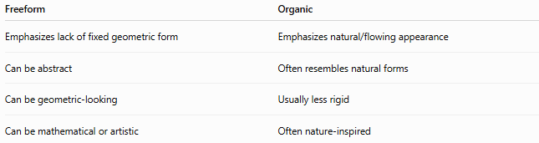
Freeform | Organic
Emphasizes lack of fixed geometric form | Emphasizes natural/flowing appearance
Can be abstract | Often resembles natural forms
Can be geometric-looking | Usually less rigid
Can be mathematical or artistic | Often nature-inspired
Therefore:
$$\boxed{\text{Organic Freeform Shapes}⊆\text{Freeform Shapes}}$$
when the organic form also lacks a fixed geometric structure.

Classification Summary
# Source: AI Source: Provided by: [Data Path: Persons Table -> ID Column: 1, Name_En Column: Motasem Essam] -> From: [ChatGPT] on [7/25/2026]
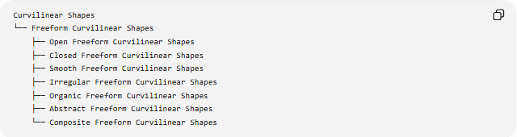
Curvilinear Shapes
└── Freeform Curvilinear Shapes
├── Open Freeform Curvilinear Shapes
├── Closed Freeform Curvilinear Shapes
├── Smooth Freeform Curvilinear Shapes
├── Irregular Freeform Curvilinear Shapes
├── Organic Freeform Curvilinear Shapes
├── Abstract Freeform Curvilinear Shapes
└── Composite Freeform Curvilinear Shapes
A more structural classification is:
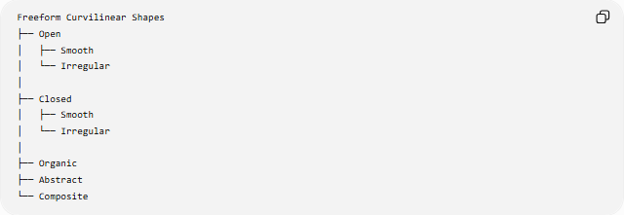
Freeform Curvilinear Shapes
├── Open
│ ├── Smooth
│ └── Irregular
│
├── Closed
│ ├── Smooth
│ └── Irregular
│
├── Organic
├── Abstract
└── Composite

Key Points
# Source: AI Source: Provided by: [Data Path: Persons Table -> ID Column: 1, Name_En Column: Motasem Essam] -> From: [ChatGPT] on [7/25/2026]
- Freeform Curvilinear Shapes use curves without a fixed standard geometric form.
- Their boundaries are primarily curved.
- They can be open or closed.
- They can be smooth or irregular.
- They can be organic or abstract.
- They can combine several curves into composite freeform shapes.
- Parametric equations are especially useful for representing freeform curves.
- Bézier and spline curves are common tools for constructing freeform boundaries.
- Freeform does not necessarily mean irregular or asymmetric.
- Freeform differs from circular and elliptical shapes because it does not require a specific standard geometric form.
- A freeform shape can simultaneously be organic, smooth, asymmetric, and closed.

Conclusion
# Source: AI Source: Provided by: [Data Path: Persons Table -> ID Column: 1, Name_En Column: Motasem Essam] -> From: [ChatGPT] on [7/25/2026]
Freeform Curvilinear Shapes are flexible curved forms whose boundaries are not constrained to a fixed standard geometric shape. They provide a broad framework for describing custom curved forms ranging from smooth organic outlines to abstract and composite curves.
The central relationship is:
$$\boxed{\text{Freeform Curvilinear}=\text{Curved Boundary}+\text{No Fixed Standard Geometric Form}}$$
They therefore occupy an important position between mathematically defined curves such as circles and ellipses and more flexible organic or abstract curved forms.

